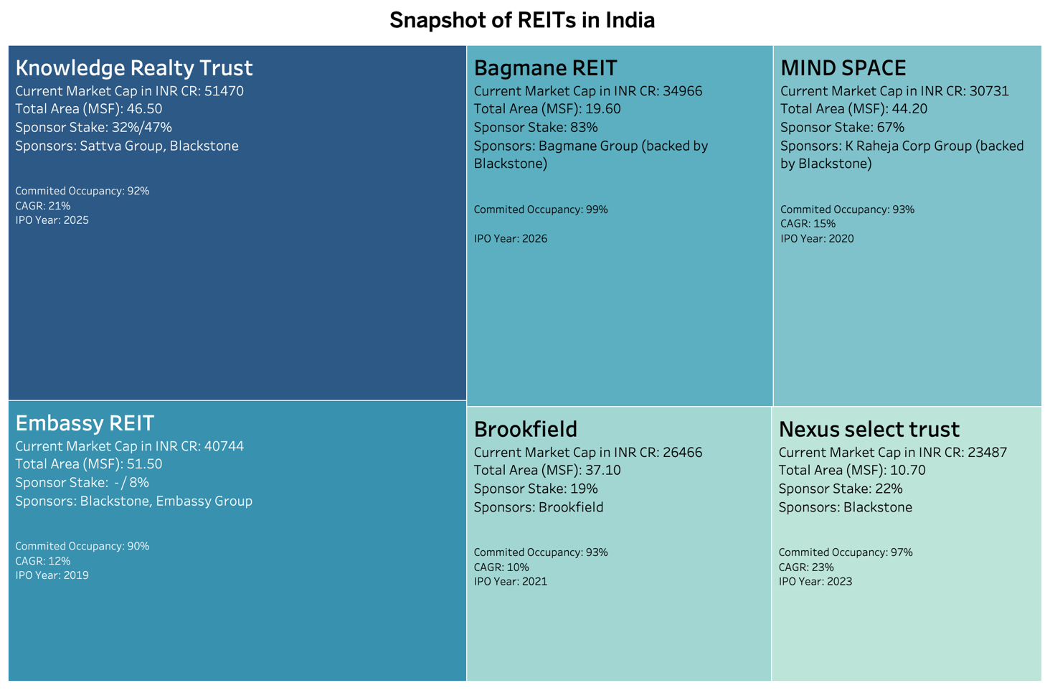
Exhibit 1: Listed Indian REITS SNAPSHOT (as at June 16, 2026)
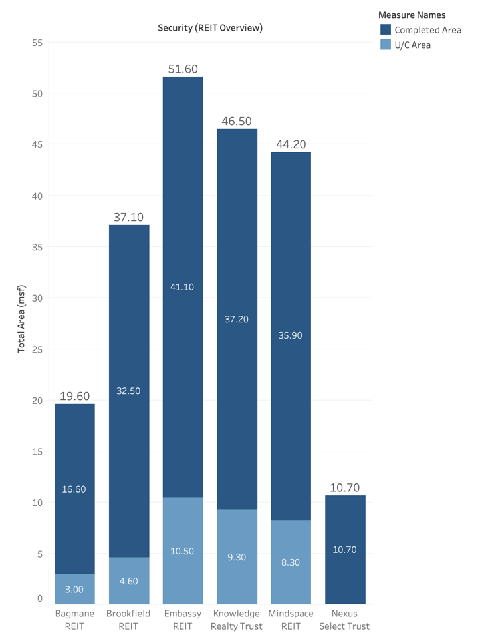
Exhibit 2: Listed Indian REITs Total Area Breakdown
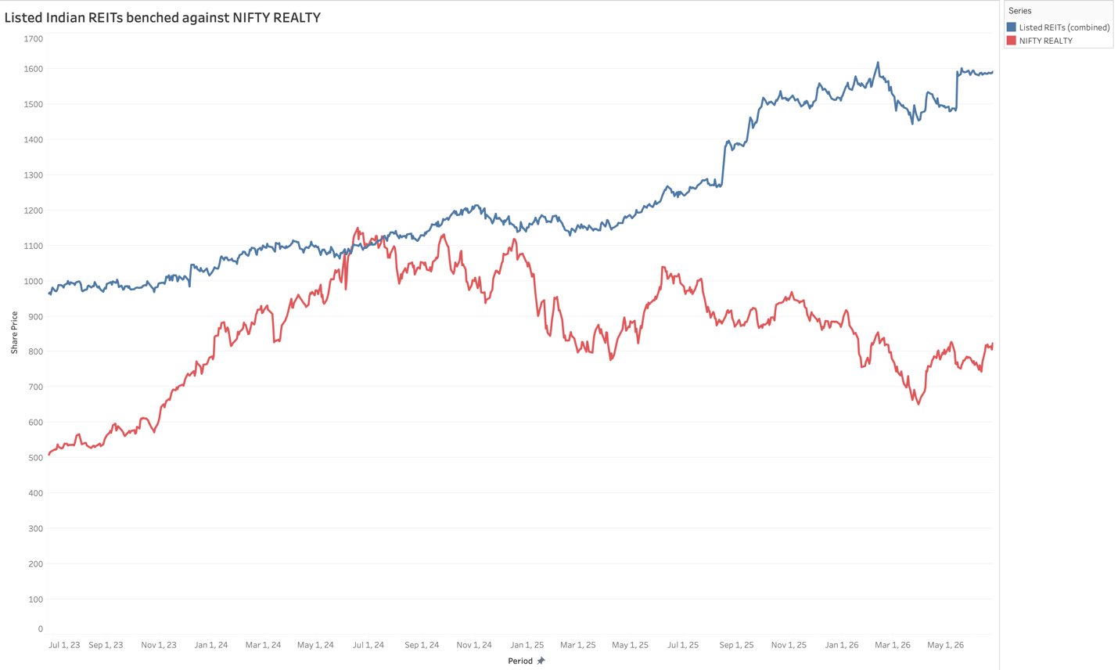
Exhibit 3: Listed Indian REITs Benched vs NIFTY REALTY

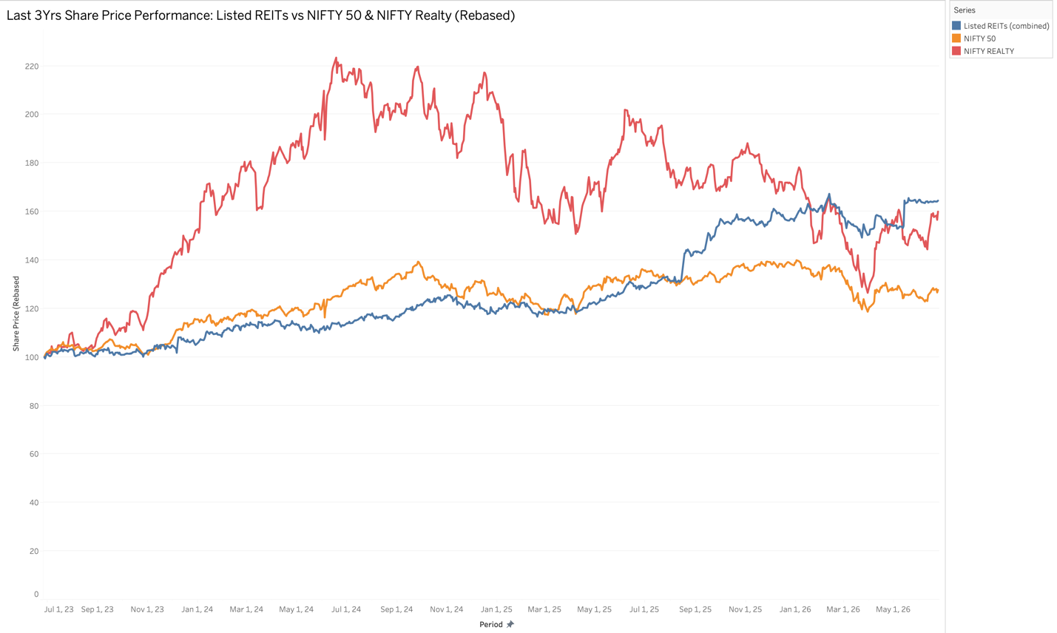
Exhibit 4: Last 3 YRs Relative Share price Performance of Listed Indian REITs vs Benchmarks
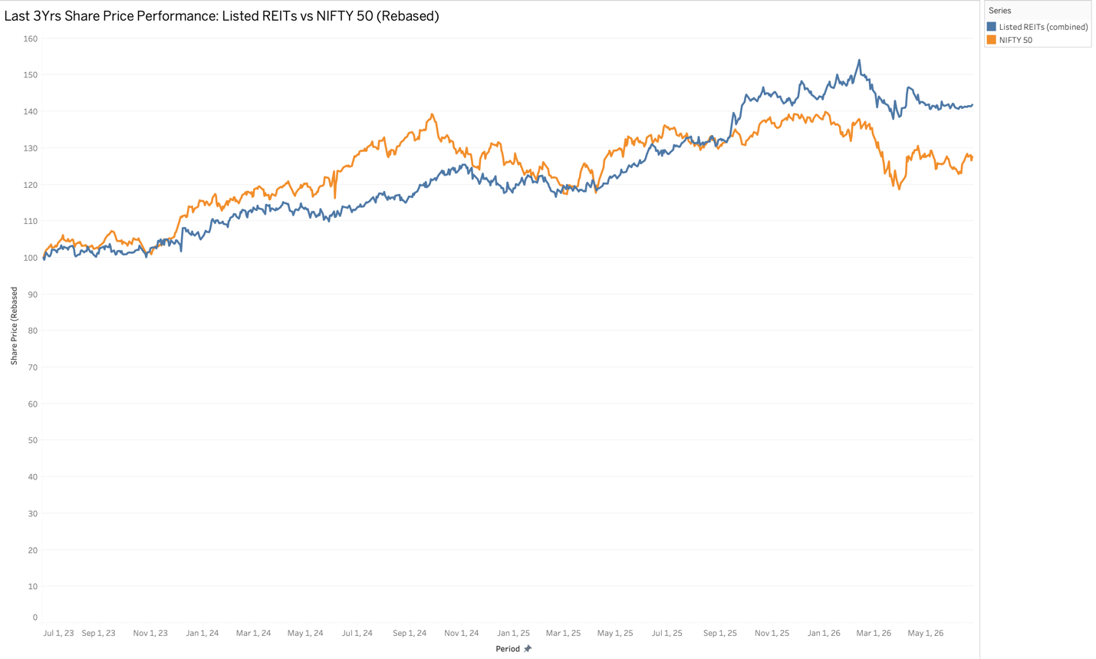
Exhibit 5: Last 3 YRs Relative Share price Performance of Listed Indian REITs vs NIFTY 50
Note: Bagmane REIT & Knowledge Realty Trust have not been included in exhibit 5 due to the recency of their IPOs.

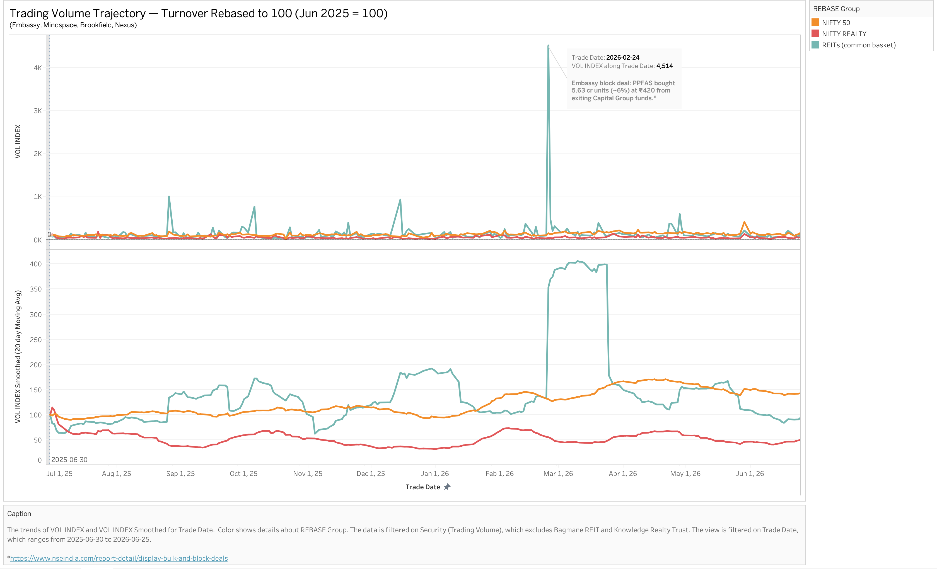
Exhibit 6: Trading Volume Trajectory REBASED

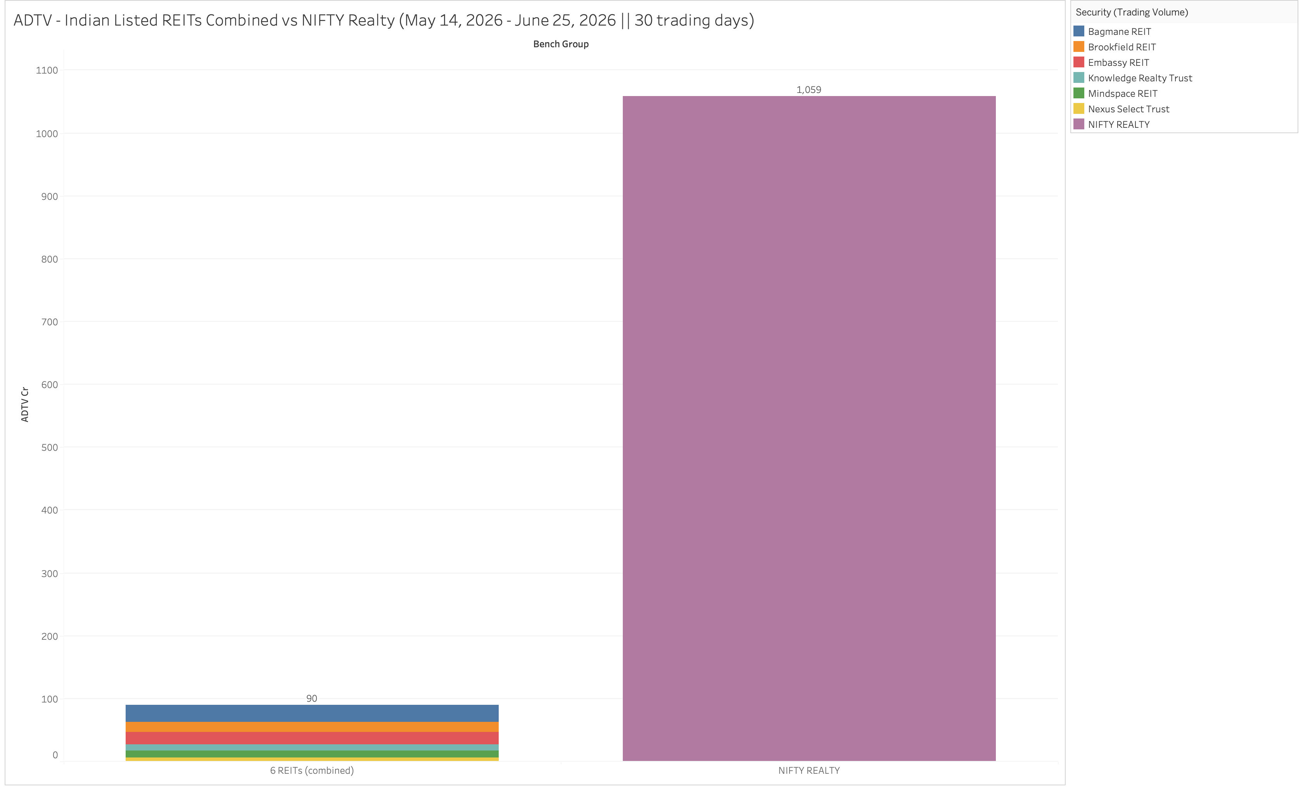
Exhibit 7: 30 day ADTV – Indian REITs benched against NIFTY Realty

